**Azure DevOps Day-10 Practice**

**DevOps Repos**

Create new DevOps Organization(azuser1049) and create a new project(hexa1049) project.

1. Create a folder using mkdir in Downloads
2. 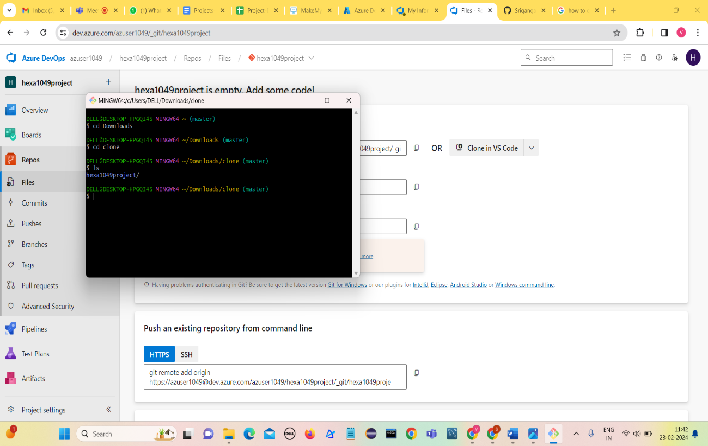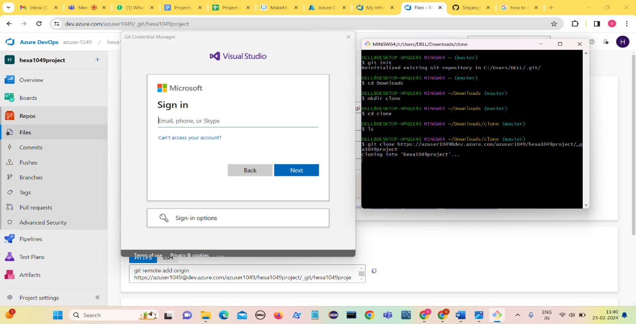Copy the URL from DevOps Git repos and using git clone to clone the repository

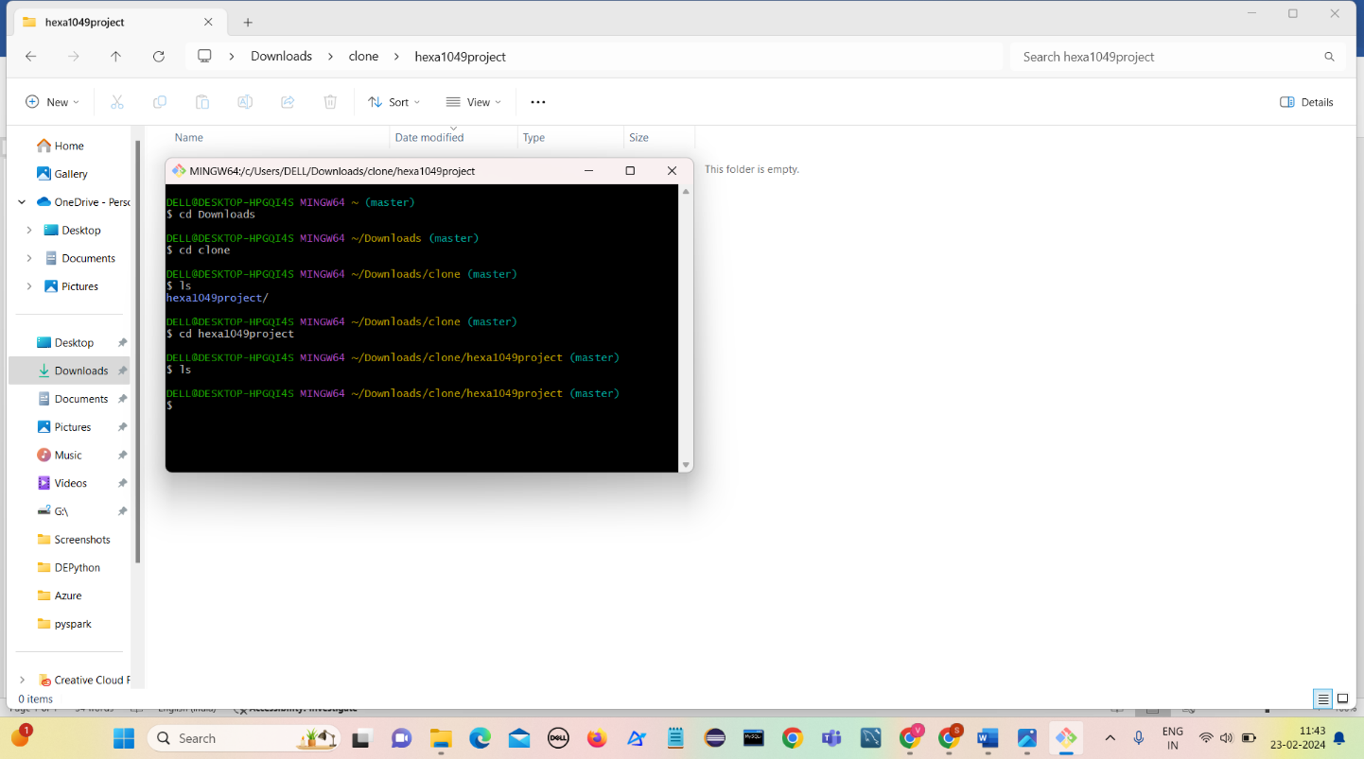

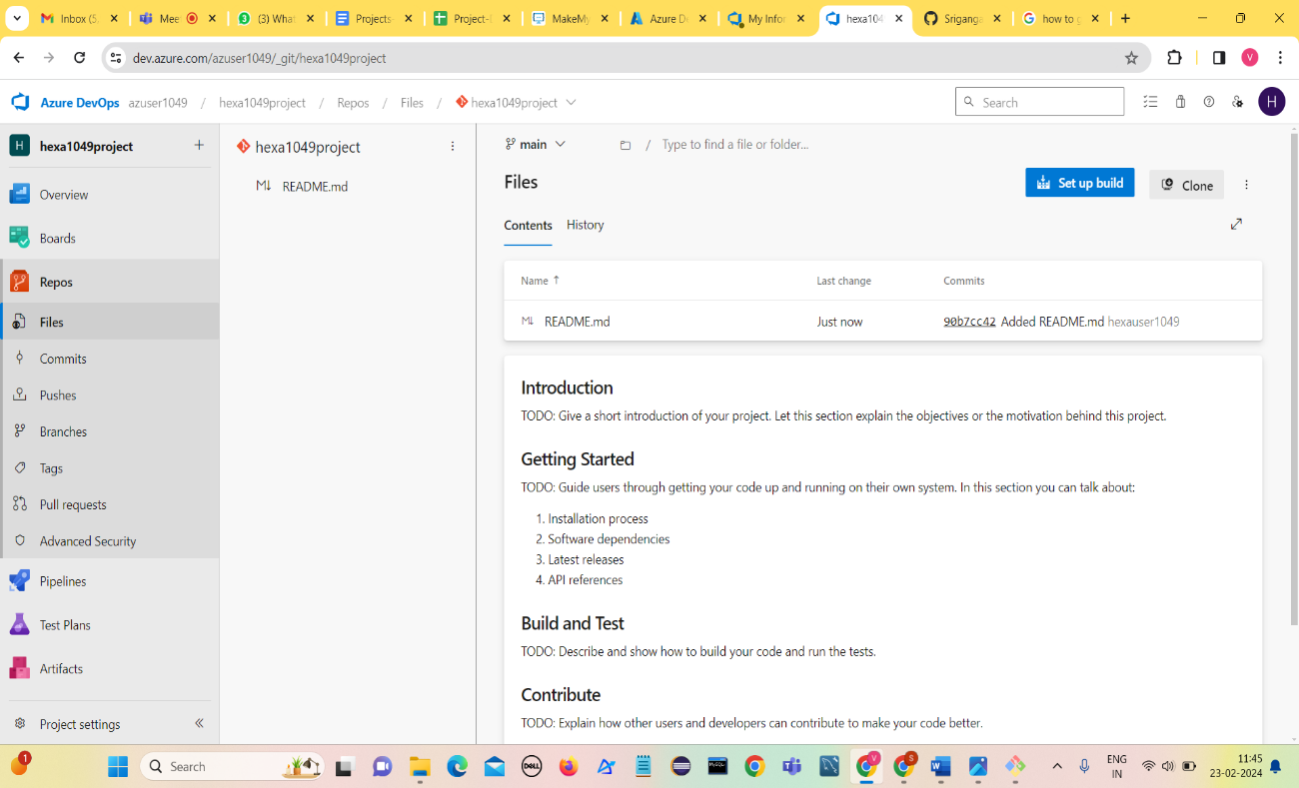Click on Initialize

Upload a file in the project

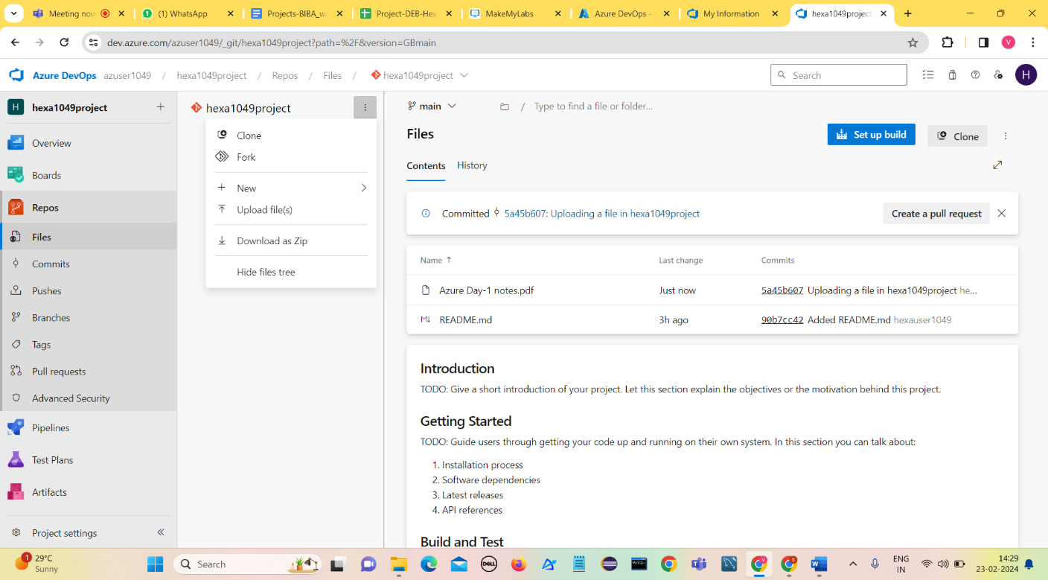

Pull the uploaded file from project to local

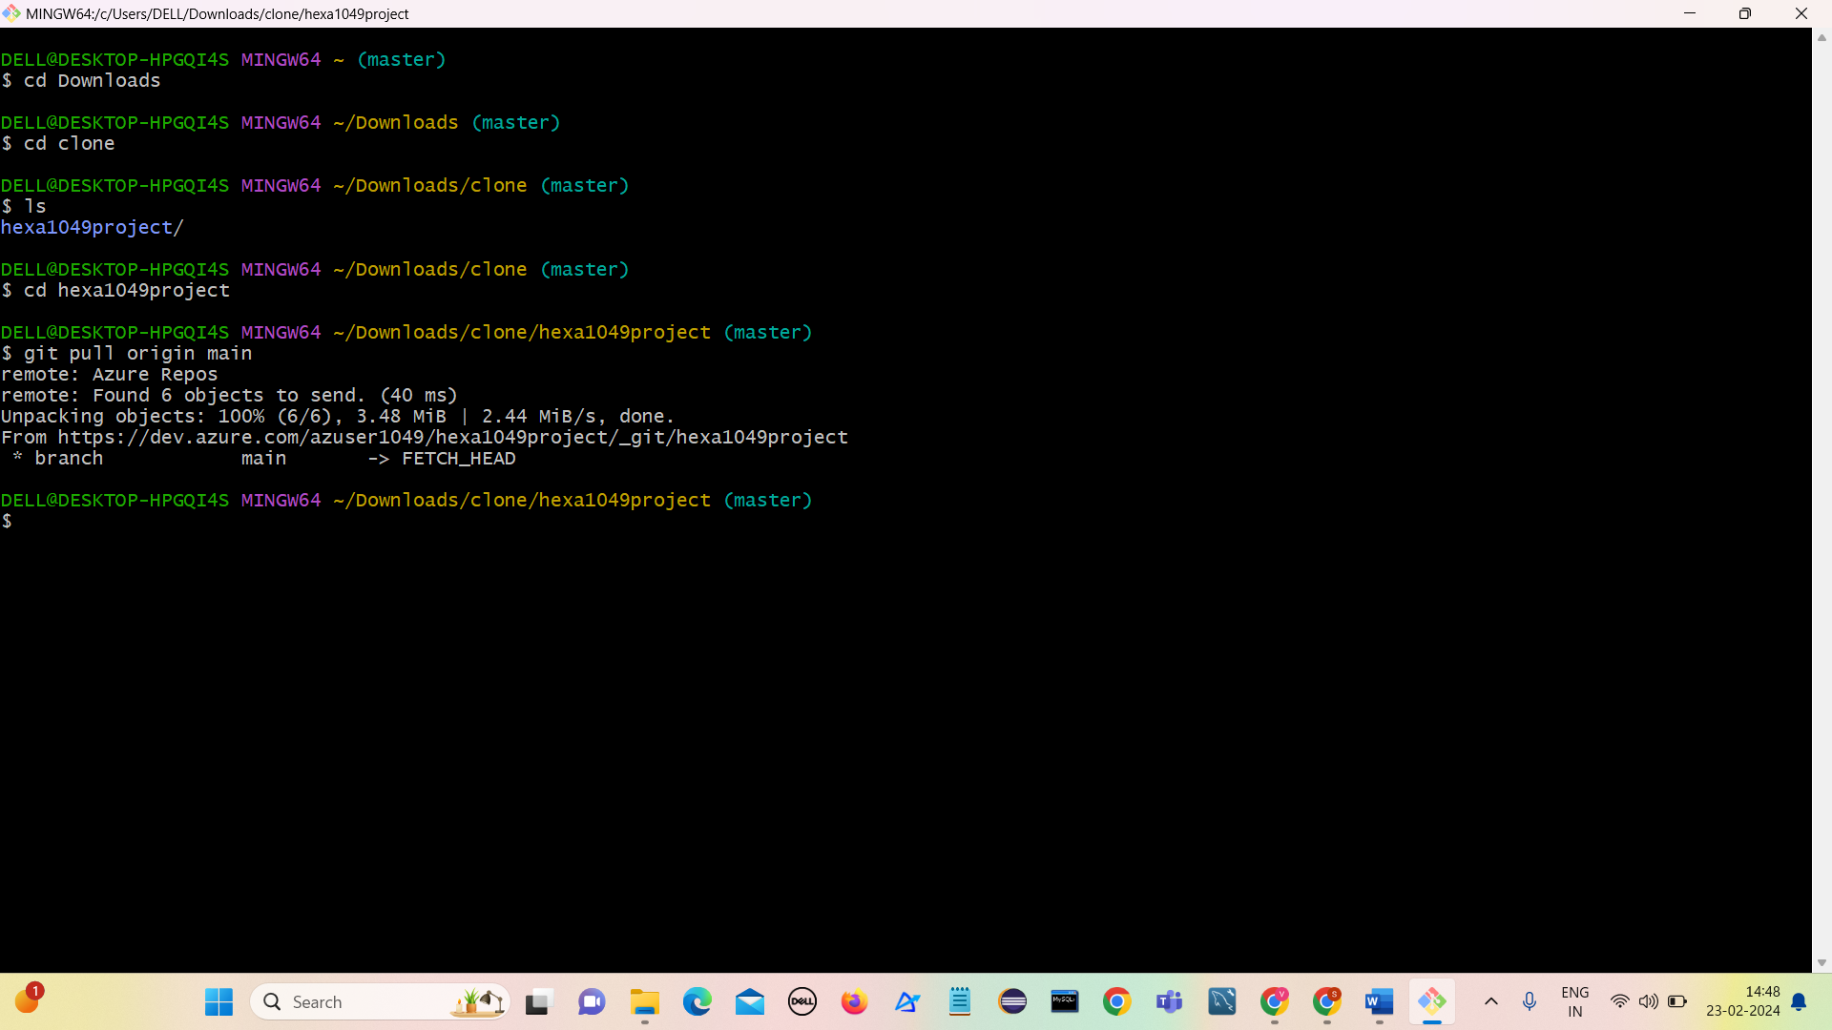

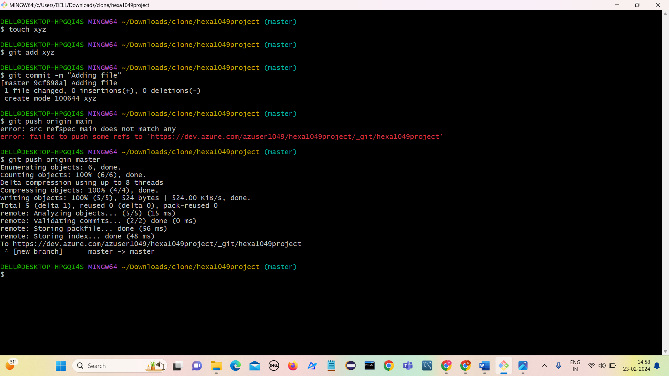Add files in project

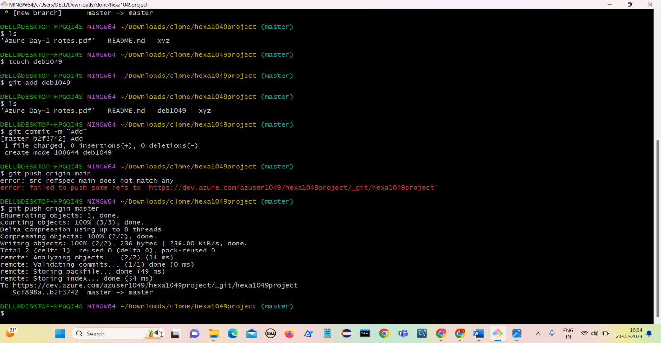

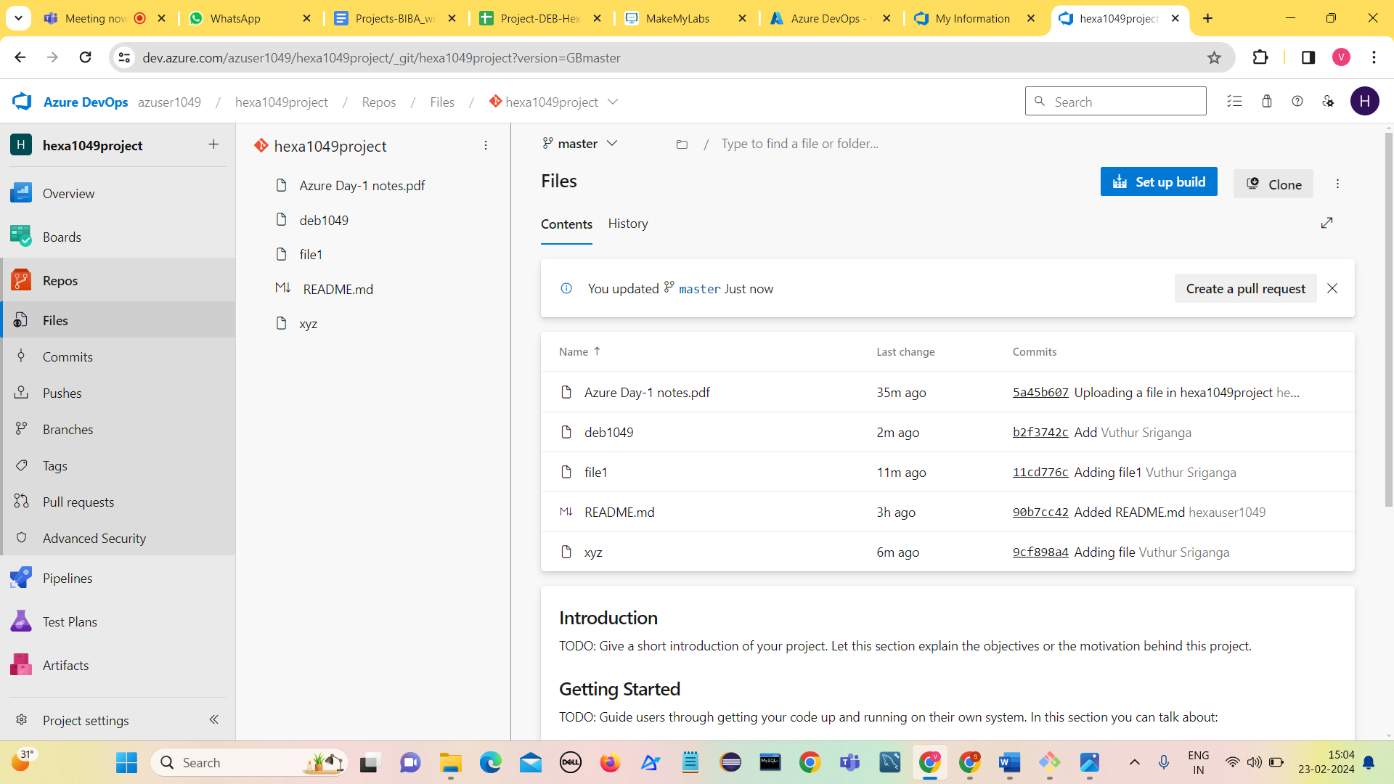

IN VSCODE

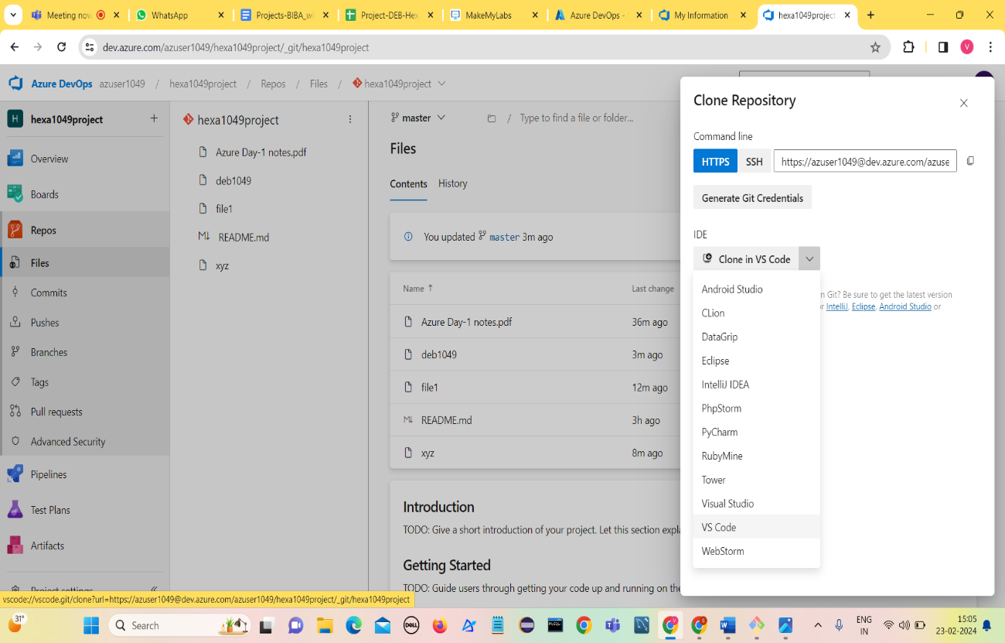

**git commands:**git init

touch filename  
git add (filename)  or git add .  
git commit -m "samplecomment"  
git push origin main/master (local to azure repos)  
git pull origin main/master (azure repos to local)

git push -u origin --all

git checkout main